Experiment No. 4

**Aim:** Query the two cities in **STATION** with the shortest and longest *CITY* names, as well as their respective lengths (i.e.: number of characters in the name). If there is more than one smallest or largest city, choose the one that comes first when ordered alphabetically.

The **STATION** table is described as follows:

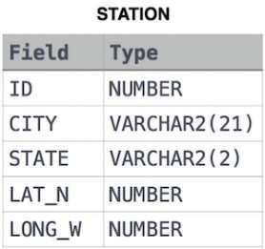

where **LAT_N** is the northern latitude and **LONG_W** is the western longitude.

**Solution:**

create table Station1(id int primary key, city varchar(150), state varchar(150), lat_N int, Long_W int);

Insert into station1 values(01, 'Mohali', 'punjab', 51, 31);

Insert into station1 values(02, 'Kharar', 'Haryana', 52, 32);

Insert into station1 values(03, 'pune', 'Maharastra', 53, 33);

Insert into station1 values(04, 'Surat', 'Gujrat', 54, 34);

Select*from Station1;

Select city, length(city) from station1 order by length(city), city limit 1 ;

Select city, length(city) from station1 order by length(city) desc, city desc limit 1 ;